**CS571: Artificial Intelligence Lab**

Indian Institute of Technology Patna



# **ASSIGNMENT 10**

Neural Networks

**Group Members**

* Kartik Mouli (2001CS35)
* Rohit Ranjan (2001CS56)
* Siddhant Kumar (2001CS70)

**Q1**: Artificial Neural Network to simulate a 2-input XOR gate.

**Result**

Learning Rate: 0.01

Epochs: 100,000

**Loss Graph**

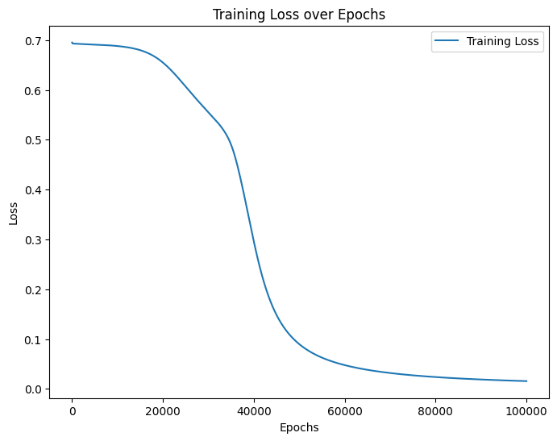

**Accuracy Graph**

**Test Prediction:**

**Conclusion:**

The XORNN successfully learns the XOR function, as evidenced by the decreasing loss and increasing accuracy. The chosen hyperparameters contribute to the convergence of the network. Further analysis and experimentation may involve varying hyperparameters or exploring additional network architectures for similar problems.

**Q2**: Multi-Layer Perceptron (MLP) classifier

**Result for IRIS Dataset:**

**Result for CIFAR10 Dataset:**

**Accuracy vs No. of Neurons Graph**

**Conclusion**

**IRIS Dataset:**

* ReLU and LeakyReLU activations perform well.
* Increasing the number of neurons generally improves performance.

**CIFAR-10 Dataset:**

* ReLU and LeakyReLU activations exhibit moderate performance.
* Increasing the number of neurons shows marginal improvements.